©
Lights
Out!

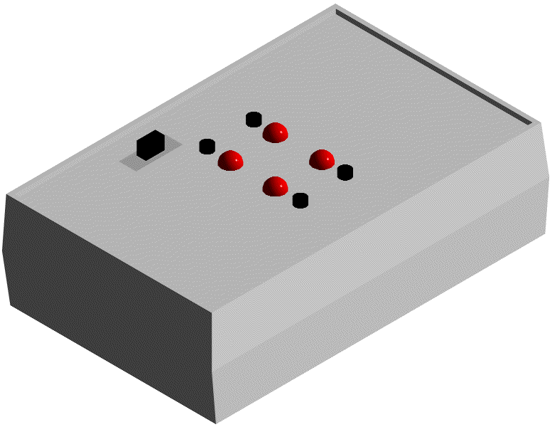
Lights Out© is an action packed new game that provides entertainment for the whole family. The object of the game is simple: try to make all of the lights turn off. The game will start will a random number of lights lit. Pressing the button next to a light switches the light from its current state. Beware, all lights that are vertical or horizontal from the one pressed are also switched!
Lights
Out!

Once I picked it up, I couldn’t put it down!

LO of Lights Out, CA
For example, suppose the lights were as shown below and button one was pressed. The lights would change as shown. You have to continue to press the buttons in order to make all of the lights turn off.
1
2
3
4
1
2
3
4
Button 1 Pressed
Lights Change

©
©
Lights
Out!

Are you up to the challenge of ?
Still interested? Visit us on the web at http://www.umr.edu/~jlai/lightsout to find out more information.
Tel: (573) 341-8945 • Fax: (978) 246-8266 • jlai@umr.edu

